KIZAD Warehouse

sITE OVERVIEW

**Brief overview**

The Central Warehouse is Located **i**n **Kizad**, wherein Departments like **Supply Chain, Fleet, Pharmacy and Education** operates**.**

|  |  |
| --- | --- |
| **Site Information** | |
| Name | **Kizad Warehouse** |
| Address | **Kizad A8, Industrial Unit # IU01, IU02 & IU03 , Al Samha Abu Dhabi** |
| Contact | **Tarek Alsabagh** |
| Mobile | **0564069542** |
| Landline | **Extension 612** |
| Website | **www.nationalambulance.ae** |
| GPS Coordinates | **24.7100228, 54.7302306** |

MAP

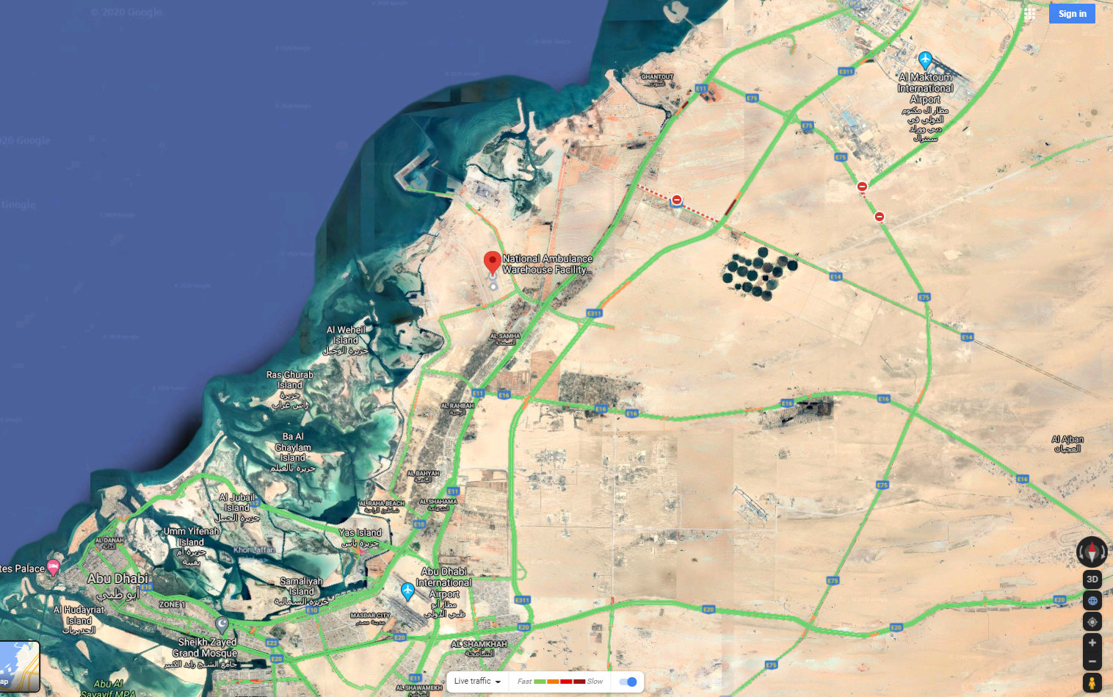

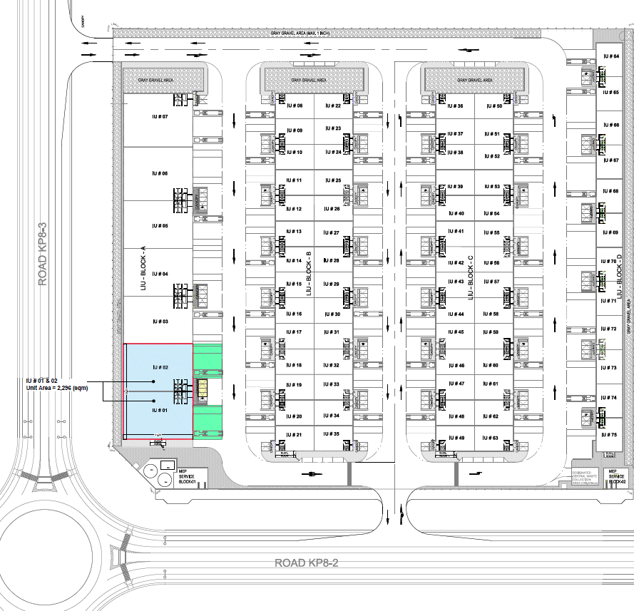

SITE ACCESS

## Abu Dhabi  - Al Shahama Rd/Sheikh Zayed Bin Sultan St/E10 and Sheikh Maktoum Bin Rashid Rd/E11 to 16th St/Al Yal St. Exit from Sheikh Maktoum Bin Rashid Rd/E11

## Continue on Al Yal St. Drive to Al Intifa' St

## At the roundabout, take the 3rd exit onto 16th St/Al Yal St, drive straight , at the roundabout, take the 2nd exit onto Al Yal St, At the roundabout, take the 2nd exit and stay on Al Yal St, At the roundabout, take the 1st exit, Turn left (tranffic signal ) onto Al Intifa' St, At the roundabout, take the 2nd exit and stay on Al Intifa' St, At the roundabout, take the 2nd exit and stay on Al Intifa' St,  At the roundabout, take the 1st exit and stay on Al Intifa' St, At the roundabout, take the 2nd exit and stay on Al Intifa' St, Destination will be on the right.